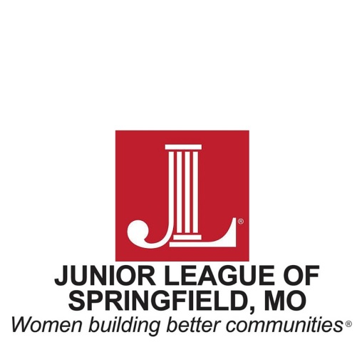

FOR IMMEDIATE RELEASE

CONTACT
Meghan Walters
Public Relations Chair
417.693.00744
communications@jlspringfield.org

Now Accepting Applications for the Building Better Communities Scholarship

SPRINGFIELD, MO. October 19, 2018 - The Junior League of Springfield (JLS) is pleased to announce that applications are now being accepted for the Building Better Communities
Scholarship. This scholarship is intended to help non-traditional female students with financial need pursuing their education in programs eligible to receive a professional certification or
license upon graduation. Scholarships in the amount of $500 will be awarded in the fall of the 2018-19 academic year. Funds will be paid directly to the designated institution and are to be restricted to tuition, books or lab fees.
As an organization of women committed to promoting voluntarism and improving the community through effective action and leadership, JLS is seeking applicants who strive to improve their education and make a difference in the community.
Eligibility Requirements (included but not limited to)
- Female non-traditional student – defined as 22 years of age and above
- Enrolled and/or accepted for the 2018-19 academic year in a program that the student is eligible to receive a professional certification or license upon graduation
- Financial need
- Submit proof of enrollment or acceptance letter at an accredited institution
- Resident of Springfield or surrounding communities
- US citizen, US national or US permanent resident
- Immediate family members of any member of the Junior League of Springfield, including Provisionals, Active and Sustaining Members and League Employees are not eligible to receive a Building Better Communities Scholarship.
The deadline for application submission is November 5. All applicants will be notified on or before November 26 if their application was chosen for a scholarship. Recipients will be recognized at the JLS December member meeting on December 4.
For more requirements and general scholarship information, please visit our webpage at JLSpringfield.org. If you have further questions, please email jlsscholarships@outlook.com.

About the Junior League of Springfield
The Junior League of Springfield is an organization of women committed to promoting voluntarism, developing the potential of women and improving communities through the effective action and leadership of trained volunteers The Junior League of Springfield reaches out to women of all races, religions and national origins who demonstrate an interest in and a commitment to voluntarism. Its purposes are exclusively educational and charitable.
Since 1959, the Junior League of Springfield has contributed more than $4 million and more than 1.3 million hours of volunteer service to the Springfield community. For more information, please visit the Junior League of Springfield website at www.jlspringfield.org.

