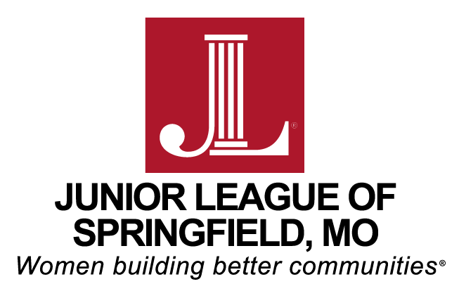

Junior League of Springfield Scholarship in
Memory of Mary Riley Wolfe
Application Materials

- Instructions for Submission
  - All application materials must be typed.
  - The application may not exceed 4 typed pages. Required attachments are not included in the 4-page limit.
  - The Application must contain the following information, in the order listed below:
    - Student name
    - Contact information including home address, phone number, and email address
    - High School name and graduation date
    - College name (if known) and anticipated area of study
    - Student profile including:
      - Community Involvement and Volunteer Impact
        - Consideration will be given to the volunteer impact the candidate has had on her community including leadership roles, volunteer awards and recognition.
      - Extracurricular Activities and Employment during high school including leadership roles
        - For extracurricular activities, please include the activity/organization, your role or position, and dates of involvement.
        - For employment, please describe employer, duties, hours worked and duration of employment.
      - Scholastic Achievements & Honors including leadership roles
      - List other scholarships and amounts received to date.

    - Required Attachments
      - Community Volunteer Experience Essay
        - This essay should describe the leadership roles you have taken, the impact on your community, and what you have learned from your high school community volunteer experiences.
        - Please limit the essay to one typed page/ 500 words or less. Applicants who exceed this will be disqualified.
      - Completed Academic Certification of GPA and Test Scores (see enclosed form)
      - Official High School Transcript
      - Two letters of recommendation
        - These letters should be written by the high school counselor, teachers, club sponsors, or supervisors from a place of employment or volunteer organization.

- Deadline for Submission
  - Applications will be accepted by email, mail or hand delivery through
April 1, 2019.

Please email submissions to:
jls@jlspringfield.org

Please mail submissions to:
Junior League of Springfield
Attn: Scholarship Committee
2574 E. Bennett
Springfield, MO 65804

- Application materials that do not comply with the above requirements will not be considered.

- Eligibility Requirements:
  - Applicants must be:
    - Female
    - A US Citizen, US National or US Permanent Resident
    - A resident of Springfield or one of its surrounding communities
    - Attending secondary school full-time
    - Anticipating high school graduation in the 2018-2019 academic year
    - Planning to pursue a degree at an accredited US post-secondary institution for the 2019-2020 academic year
    - Maintaining a minimum unweighted GPA of 3.5 on a 4.0 scale
  - Immediate family members of the Junior League of Springfield which includes New Members, Active and Sustainers as well as League employees are not eligible to receive a League Scholarship.

- Scholarship Awards:
In the 2018-2019 academic year, the Junior League of Springfield anticipates awarding two $2,000.00 scholarships to two young women in our community in order to assist the recipients with the expenses of their college education. Funds will be paid directly to the designated institution and are to be used only for tuition, books, or lab fees.

