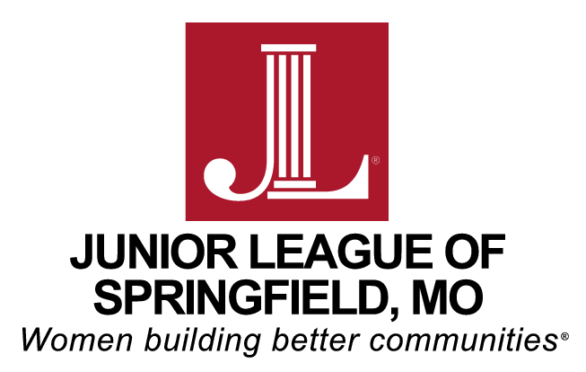

Table of Contents

I. Instructions Page 2

II. Definitions and Selection Criteria Page 3

III. Grant Request Application Form Pages 4 - 5

Mission
The Junior League of Springfield, Inc is an organization of women committed to promoting voluntarism, developing the potential of women, and improving the community through the effective action and leadership of trained volunteers. Its purpose is exclusively educational and charitable.

Vision
Women Building Better Communities.

Values
The Junior League of Springfield values:
- The necessity and significance of women exercising leadership throughout the community.
- Training and education that advance our personal and professional leadership skills.
- Advocacy for issues impacting women and children.
- An environment that encourages diversity of opinions and supports multi-generational engagement.
- Each member’s unique needs for engagement in the League.

Instructions

- Proposal must be filled out using the format provided.

2. Proposals must be typed.

- Proposal is not to exceed 4 pages, no exceptions. Requested appendices are not included in the 4 page proposal limit.

- Projects must commence between June 1, 2020 and May 31, 2021.

- Proposals are due October 4, 2019 by 5:00pm.
Email proposals:
communityimpact@jlspringfield.org

- ADDITIONAL PAGES THAT MUST BE SUBMITTED:
  - Project Budget – insert as Appendix A
  - Agency Board of Directors – insert as Appendix B
  - 501(c)(3) Tax Exempt Status Form – insert as Appendix C
  - Reviewed or Audited Financial Statement – insert as Appendix D
  - 990 Tax Returns – insert as Appendix E

- If you are coordinating with or serving another agency (i.e., public schools, church, etc.), their approval and commitment to this project must accompany your proposal in writing as an attachment to your proposal. Insert this letter as Appendix F.

- All selected projects must adhere to the Junior League of Springfield’s purchasing policies. The Junior League of Springfield will request documentation of all expenditures, and has the right to exclude payment for items that do not fall under the project description. Any monies not spent within the specified project dates will be automatically excluded.
DEFINITIONS

Agency: | The organization requesting funding that has been granted exemption from Federal Income Tax under the provisions of Section 501(c)(3) of the Internal Revenue Code. This agency is not a private foundation.
Project: | A planned undertaking to be approved by the Junior League of Springfield’s membership and organized to serve the community in the area of Child Abuse and Neglect. The Junior League of Springfield assumes volunteer, administrative and financial responsibilities.
Placement: | Voluntary community service required of active Junior League of Springfield members. Quality placements should provide an interesting and fulfilling volunteer experience.

Agency Name:

Address:

Contact Name: Contact Title:

Phone #: E-mail Address:

Project Title:

Dollar Amount Requested:

Number of Volunteers Needed:

Specify Date or Dates of Project:

Weekday or Weekend Project:

Day or Evening Project:

Complete Description of Project (including the purpose and goal):

Population this Project will serve:

Volunteer positions that you are requesting with descriptions:

Are there other organizations working with you on this Project? If yes, please describe.

Your agency’s Mission:
Please include the following attachments:

  - Project Budget – insert as Appendix A
  - Agency Board of Directors – insert as Appendix B
  - 501(c)(3) Tax Exempt Status Form – insert as Appendix C
  - Reviewed or Audited Financial Statement – insert as Appendix D
  - 990 Tax Returns – insert as Appendix E
  - Coordinating agency letter (if applicable) – insert as Appendix F

