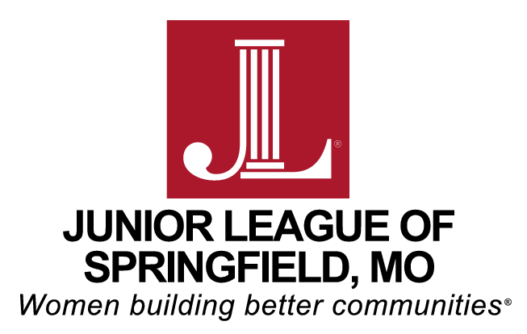

Table of Contents

I. Instructions Page 2

II. Definitions and Selection Criteria Page 3

III. Grant Request Application Form Pages 4 - 5

Mission
The Junior League of Springfield, Inc (JLS) is an organization of women committed to promoting voluntarism, developing the potential of women, and improving the community through the effective action and leadership of trained volunteers. Its purpose is exclusively educational and charitable.

Vision
Women Building Better Communities.

Diversity & Inclusion Statement
The JLS welcomes all women who value our Mission. We are committed to inclusive environments of individuals, organizations and communities.

Values
The Junior League of Springfield values:
- The necessity and significance of women exercising leadership throughout the community.
- Training and education that advance our personal and professional leadership skills.
- Advocacy for issues impacting women and children.
- An environment that encourages diversity of opinions and supports multi-generational engagement.
- Each member’s unique needs for engagement in the League.

Instructions

- Proposal must be filled out using the format provided.

2. Proposals must be typed.

- Proposal is not to exceed 4 pages, no exceptions. Requested appendices are not included in the 4 page proposal limit.

- Agencies may submit a proposal for one of two types of projects: Done in a Day (short-term) or Done in a Year (long-term).

  - Done in a Day (short-term) Projects must commence between June 1, 2021 and May 31, 2022.
  - Done in a Year (long-term) Projects will require additional research and follow-up by the Junior League of Springfield’s Project Review & Development Committee. If selected, these projects would likely not be implemented until at least June 2022.

- Proposals are due October 2, 2020 by 5:00pm.
Completed proposals should be emailed to: communityimpact@jlspringfield.org

- ADDITIONAL PAGES THAT MUST BE SUBMITTED:
  - Project Budget – insert as Appendix A
  - Agency Board of Directors – insert as Appendix B
  - 501(c)(3) Tax Exempt Status Form – insert as Appendix C
  - Reviewed or Audited Financial Statement – insert as Appendix D
  - 990 Tax Returns – insert as Appendix E

- If you are coordinating with or serving another agency (i.e., public schools, church, etc.), their approval and commitment to this project must accompany your proposal in writing as an attachment to your proposal. Insert this letter as Appendix F.

- All selected projects must adhere to the Junior League of Springfield’s purchasing policies. The Junior League of Springfield will request documentation of all expenditures, and has the right to exclude payment for items that do not fall under the project description. Any monies not spent within the specified project dates will be automatically excluded.

- Questions can be directed to Ashley Silva, Project Review & Development Committee Chair, at communityimpact@jlspringfield.org

DEFINITIONS

Agency: | The organization requesting funding that has been granted exemption from Federal Income Tax under the provisions of Section 501(c)(3) of the Internal Revenue Code. This agency is not a private foundation.
Project: | A planned undertaking to be approved by the Junior League of Springfield’s membership and organized to serve the community serve the community in ways that align with the Junior League of Springfield’s mission, vision, values and D&I statement. The Junior League of Springfield assumes volunteer, administrative and financial responsibilities.
Placement: | Voluntary community service required of active Junior League of Springfield members. Quality placements should provide an interesting and fulfilling volunteer experience.
Diversity: | Term that describes the presence of individuals from various backgrounds and/or with various identities. The term is often used to include aspects of race, ethnicity, gender, sexual orientation, class, and ability*
Inclusion: | The degree to which individuals with diverse perspectives and backgrounds are able to participate fully in the decision-making processes of an organization or group**
Equity: | Improving equity is to promote justice, impartiality, and fairness within the procedures, processes, and distribution of resources by institutions or systems. Tackling equity issues requires an understanding of the underlying or root causes of outcome disparities within our society.**

*Baltimore Community Foundation, DEI Definitions of Terms. Drawn from Baltimore Racial Justice Action. 2014

** D5 Coalition, State of the Work: Stories from the Movement to Advance Diversity, Equity, and Inclusion, 2016.

- Agency Name:

- Agency Address:

- Contact Name:

- Contact Title:

- Phone Number:

- E-mail Address:

- Your agency’s Mission:

- Project Title:

- Please indicate what type of project this will be
  - Done in a Day Project (short-term)
  - Done in a Year Project (long-term)

- Amount of Funding Requested:

- Number of Volunteers Needed:

- Specific Date or Dates of Project:

- Weekday or Weekend Project:

- Day or Evening Project:

- Complete Description of Project (including the purpose and goal):

- What population will this project serve?

- Please provide a brief overview of the volunteer positions that you are requesting:

- Are there other organizations working with you on this Project? If yes, please describe.

- Please provide a brief description of how your organization is embracing diversity, equity, and inclusion in your work:

- Please include the following attachments:

  - Project Budget – insert as Appendix A
  - Agency Board of Directors – insert as Appendix B
  - 501(c)(3) Tax Exempt Status Form – insert as Appendix C
  - Reviewed or Audited Financial Statement – insert as Appendix D
  - 990 Tax Returns – insert as Appendix E
  - Coordinating agency letter (if applicable) – insert as Appendix F

